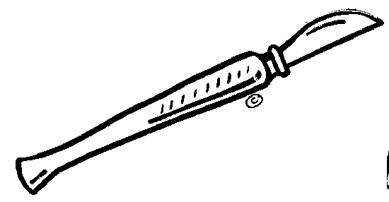 Name:

Biology 1 Name:

***Flower Dissection*** Date:

***Activity*** Hour:

Gregor Mendel was an Austrian monk famous for his laws and predictions describing inheritance through sexual reproduction. To better understand how and which traits are passed from parent to offspring, many observations were necessary. To visualize the results of multiple matings, Mendel needed a sexual organism that produced many offspring. His choice was the pea plant.

Many plants (including peas) are sexual reproducers. To fully appreciate Mendel’s techniques and findings, it is important to understand the sexual structures, gametes and reproductive strategies of flowering plants. A thorough flower dissection will reveal many of these.

A dissection is meant to afford an opportunity to get a first-hand look at how a living thing is put together. Drawings will be necessary. Labeled sketches are an important method for confirming observations. The purpose of the drawings is to show how the main structures of the organism relate to each other. Drawings do not need to be of "art" quality, but they must be neatly done and labeled.

**Background Information**:

Every flower consists of a set of adaptations that help to ensure successful reproduction. For example, flowers often have bright colors, attractive shapes, and pleasing aromas. These traits help them attract insects and other animals that will carry pollen grains from flower to flower. Pollination also occurs by means other than animals carrying the pollen. For some flowering plants, the wind plays an important role in transferring pollen from plant to plant.

The seed-bearing plants that produce flowers are **angiosperms**. The flower produces the seeds, each of which contains a new plant embryo. The parts of the flower are usually found in whorls, or rings. **Petals** are one of the sets of whorls. They attract pollinators. **Sepals** lie outside the petals. They protect the bud.

The reproductive organs, the stamens and pistils, lie inside the petals. A **stamen** is a male reproductive part. It consists of an anther that is held up by a **filament.** The **anther** produces pollen grains. A **pistil** is a female reproductive part. Its top is called the **stigma.** It is sticky to ensure that when pollen grains land on it, they stick to it. The middle supporting structure is the **style,** and the large base is the **ovary,** where the eggs are produced.

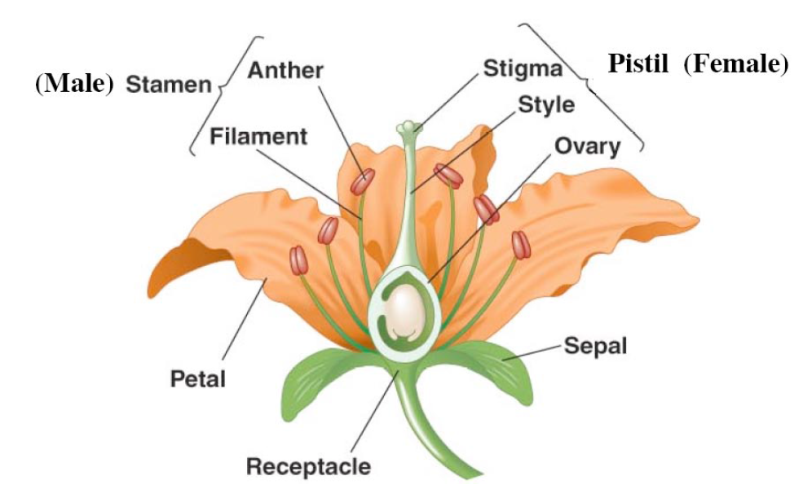

**Materials:**

Flower, Forceps, Magnifying Glass, Glue/Tape, Scalpel/Razor (optional)

**Procedure:**

1. Locate the outermost layer of flower parts. These are the sepals *(there may or may not be sepals*

*depending on the type of flowers Mr. Logsdon provides).* Carefully remove the sepals.

2. Identify the petals. These form the next layer of flower parts. Carefully remove each petal.

Attach one in your data table.

3. Now locate the stamen. These male flower parts should now be exposed. Record the number of

stamen and attach one in your data table.

a. What do anthers produce? ________________________________

b. Name the flower part that elevates the anther. __________________________

c. Why is it important to elevate the anthers? ________________________________

____________________________________________________________________

d. Describe two different ways that a pollen grain can get to the stigma of a pistil.

_____________________________________________________________________

_____________________________________________________________________

e. Flowers usually contain more stamen than pistils. Why do you think this is?

_____________________________________________________________________

_____________________________________________________________________

_____________________________________________________________________

4. The female flower part remains. Read the following passage to better understand and identify

the female portion of your flower.

|  |  |  |
| --- | --- | --- |
| *http://www.howe.k12.ok.us/~jimaskew/carpels.gifIn many plant species, the carpels may be fused, making several combinations possible.*  *At the right, (A) shows a single pistil consisting of several fused carpels setting on a receptacle and (B) shows several pistils, each consisting of a single carpel.* ***Circle which type your flower is like.*** | |  |
| *http://www.howe.k12.ok.us/~jimaskew/positions.gif* | | *Ovary position may differ from one species to another. On the left, (A) shows an ovary above the attachment of the sepals. The ovary is superior, the flower Hypogynous. (C) shows an ovary below the attachment of the sepals. The ovary is inferior, the flower Epigynous. (B) is an intermediate possibility, the ovary is superior but surrounded by, and free from, a receptacle formed by the sepals. This flower is Perigynous.* ***Circle which type your flower is like.*** |
| *The ovary may consist of one or more chambers or locules which contain one or more undeveloped seeds, the ovules. The area of the ovary wall where the ovules are attached is called the placenta. The arrangement of the placenta varies in different species.*  *Plants like peas have a pistil consisting of a single carpel, the placenta occurs on the ovary wall opposite the main vein. In flowers where the pistil consists of more than one fused carpel the situation is more complex.* | | |
| *Cross-section (A) shows parietal placentation, with the placentas attached to the outer ovary wall, with carpels attached in the center. Cross-section (B) shows axile placentation of the ovary.*  *The ovary may have only one chamber despite consisting of several fused carpels. This central placenta is known as free central placentation. (C) shows central placentation in cross-section and (D) shows it in longitudinal section.* ***Circle which type your flower is like.*** | http://www.howe.k12.ok.us/~jimaskew/ovules.gif | |

a. Record the number of pistils and attach one in your data table.

b. Name the flower part that elevates the stigma. ____________________________________

c. Why is it important to elevate the stigma?

______________________________________________________________________________

d. How does the structure of the stigma aid in pollination?

______________________________________________________________________________

______________________________________________________________________________

e. Which parts of the flower develop into the seeds? ____________________________________

**Dissection Wrap-up Questions**

1. Common name of your flower: _____________________________________

2. Scientific name of your flower: _____________________________________

Use a magnifying lens to examine each of the following parts. Record how many you find in your simple flower. Sketch and label the parts of the flower. An example is provided for you.

Labeled Sketch of Your Flower

*Count and record how many of each your flower has:*

3. Anthers? _______   
4. Pollen grains? (Estimate of tiny yellow specks on the anther)           _______   
5. Pistil(s)? _______   
6. Ovules? (Small specks found inside the ovary at the bottom of the pistil) _______

7. Describe smell of your flower: __________________________________________________

|  |  |  |  |
| --- | --- | --- | --- |
| Petal | Anther | Pistil | Pollen *(if present)* |

Carefully remove one of each of the following and place it on the appropriately labeled square.

8. Pollen grains are the male sex cells of the flower.  Eggs are the female sex cells.

When the pollen is brought to the female part of the flower it is called pollination. Why do you think that the pistil is sticky at the top?

 

9. Why do you think flowers are brightly colored?

10. There are a few different ways that pollen can be brought to the pistil: insects, wind, birds, animals and water. Which do you think pollinates your flower and why?

1. The male sex cells in the pollen are called sperm. When the sperm and eggs combine, sexual reproduction occurs and the egg is fertilized.  The fertilized egg becomes a seed.   
   Where would you predict you would find seeds in a fertilized flower?
2. How many seeds could your flower produce? (an estimate) _______________